North Scarle School

SEND Information Report September 2025

How will you know if my child needs extra help?

We aim to identify children with special needs as soon as possible at North Scarle. However, it is important to consider that all children enter school with different experiences, progress at different rates and attain different academic levels. Staff working directly with your child may raise a concern if he/she does not appear to be making the expected progress over a few weeks. Perhaps they appear to be falling significantly behind the level of their classmates, despite working hard, or you yourself, may notice that they don’t appear to be improving in their learning.

Usually, a child will be identified in one of the following ways.

- Information from a pre-school setting
- A pupil performing significantly below the expected level for their age
- A parent or carer expressing a concern
- Concern raised by a member of school staff, for example where self esteem or behaviour appears to be affecting performance
- Information received from external agencies regarding physical difficulties or a health diagnosis from a paediatrician.

What should I do if I think my child needs extra help?

Please talk to us! Members of staff at North Scarle are approachable and parents should feel they can discuss any issue that may be worrying them regarding their child’s time at school. Every morning between 8:40 – 8.45am a member of staff is available at the school gate. At the end of every day, all staff are available to chat to at the school gate. If you prefer, you can request a formal appointment, or perhaps you might feel more comfortable speaking over the telephone or writing to us. The main thing is, to share your concern with us. We will always try to be open and honest with parents and we hope they feel able to take the same approach with us.

Where can I find the school’s SEND policy and other related documents?

SEND stands for Special Educational, Needs and Disability. You can find all this information on the school’s website or you may request a paper copy from the school administrator. abbie.palmer@northscarleprimary.co.uk

How will you teach and support my child?

Our aim is for all children, regardless of their need, to be given the opportunity to take part in appropriate learning opportunities in an inclusive manner. Staff are expected to deliver high quality class teaching which is differentiated to meet the needs of all our learners.
Within the classroom setting you may find that your child:

- Uses alternative forms of recording their work
- Uses physical or mobility aids
- Uses additional visual prompts
- Works in small focus groups with an additional adult
- Works 1:1 with an additional adult
- Takes part in an intervention programme, available to support children who require help in a specific area which goes beyond the work available in class.
- Works with a specialist teacher, for example a Speech and Language Therapist, Occupational Therapist or Specialist Outreach Teachers –STAPS who may support children with autism or dyslexia.

If your child receives significant, additional levels of support, a written plan will be created for him/her. This will detail the specific areas of learning, targets and strategies they are using to improve. You will receive a copy of this, so you are fully aware of how your child is being supported at school.
The targets set are SMART (Specific, Measurable, Achievable, Realistic, Time scaled), with the expectation that the child will achieve the target by the time it is reviewed. The plan is regularly reviewed and updated throughout the year, and you will have the opportunity to discuss your child’s progress at regular parent- teacher meetings. You can, of course, access the Head teacher, SENCO or members of the support staff for updates at any time. (The SENCO is the named teacher in charge of children on the special needs register).

How will the curriculum and learning environment be matched to my child’s needs?

North Scarle is a small school, and as such, staff pupil ratios tend to be very favourable. Classes consist of more than one year group, so teachers have become extremely proficient at providing activities in any one lesson which span a wide ability range. All work within class is pitched at an appropriate level so that children are able to access it according to their specific needs. Typically, this might mean that in a lesson there would be three different levels of work set for the class. Teaching Assistants are very experienced and have the ability to deliver individually differentiated activities and use their initiative to intervene when learning objectives need to be broken down into even smaller steps. Class teachers are encouraged to discuss approaches to differentiation with specialist staff. Teaching assistants attend sessions provided by outside agencies in order to ensure continuity of approach between visits. There are regular discussions between teaching assistants, class teachers and SENCO regarding pupil progress.

How is the decision made about what type, and how much support my child will receive? Who will make the decision and on what basis?

When your child’s needs are initially discussed, the provision he/she needs will be agreed upon. It is important that the school, parents and pupils work together at this stage. If there are differences of opinion about the nature of support required, or very specialist support is suggested, the school may seek the advice of external agencies to help in the decision-making process. See below the SEND journey flow chart that school follow.

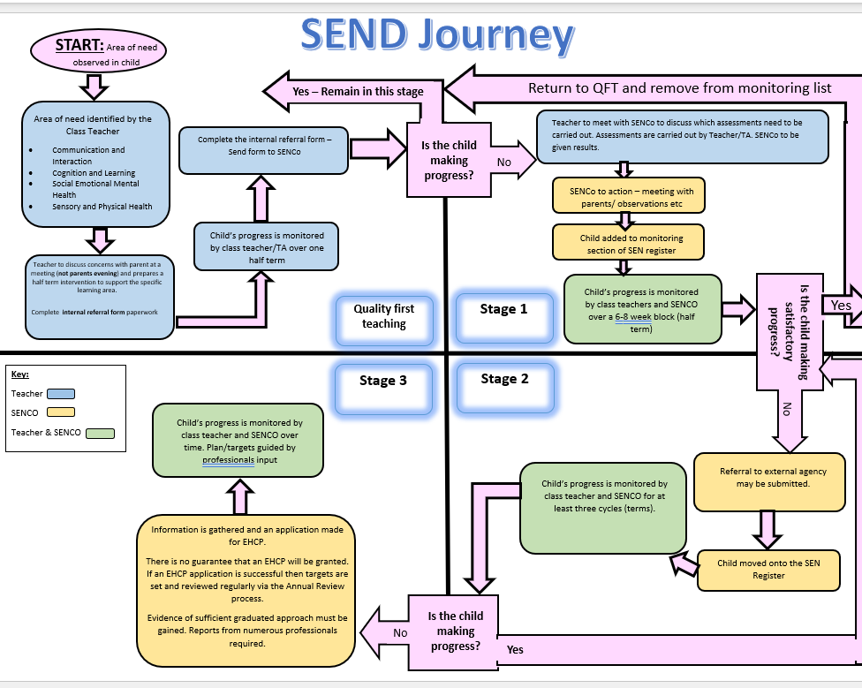

How will the equipment and facilities to support children with SEND be secured?

There is a budget set aside in school to support children on the special needs register. In order to make sure that learners with SEND have the required resources in each classroom, a proportion of the SEND budget is used towards class-based provision. This might take the form of additional physical resources e.g. enlarged visual aids, additional ICT equipment, writing slopes, alternative seating etc. Class teachers are encouraged to discuss their resource needs with the SENCO and Head teacher.
For those requiring provision additional to class-based approaches, funding facilitates the school’s range of intervention programmes. In some cases, it might also be used to provide additional human resources e.g. teaching assistants, therapists, specialist teachers etc. Specialist training of staff may also be necessary. Funding is applied using a flexible approach, to enable pupils to achieve specific outcomes at any time. The SEND budget is the responsibility of the Head teacher and SENCO, and regular discussion and monitoring takes place to ensure that resources are allocated appropriately and cost efficiently. Where much more specialist personalised equipment is required, the school SENCO or Head teacher liaise with the relevant external advisory service (e.g. occupational therapy, sensory impairment services) to seek advice on the best options for the procurement of these. Parents will be involved wherever possible in these discussions.

How will you and I know how my child is doing, and how will you help me to support their learning?

School staff have high expectations for all learners. Teachers monitor children’s progress on a day to day basis through a range of assessment types. For learners with the most significant needs, daily contact with families takes place, for example through informal conversation at the end of the school day or sometimes in home-school books. As a school, we measure children’s progress in learning against National expectations and age related expectations. It is the class teacher’s responsibility through discussion with Teaching Assistants to note areas of improvement and where further support is needed. We track pupil’s progress from school entry to Year 6. Children who are not making expected progress are picked up through discussion between teachers, teaching assistants, SENCO, Head teacher and parents. Individual tracker graphs showing smaller steps of progress within wider National Curriculum Levels are drawn up as a measure of progress.
Information about pupil progress is shared with parents at two parent-teacher meetings. Parents with children on the special needs register are encouraged to seek additional appointments to discuss their child’s progress at any time.
If a child has not met a target on their plan, the reasons for this will be discussed, then the target may be adapted into smaller steps or a different approach may be tried to ensure the child does make progress. The annual school report is sent home during the summer term.

How does the school consult with and involve children with SEND in planning and reviewing their education?

At North Scarle we encourage all pupils to have a viewpoint. Children who are on the special needs register discuss and set their targets with their class teacher, these are put into a Learning Passport which is shared with staff, parents and the child. The Child’s voice is reflected in this document as well as Parent’s views. Each time a review of the targets, as part of the plan-do-review cycle, takes place parent’s and the child’s views are collated and help to form the planning of new targets. They are encouraged to evaluate for themselves whether targets have been met and if not, what strategies they can use to improve. Periodically a pupil questionnaire is used, where we actively seek the viewpoints of children. Pupils are encouraged to speak to a trusted adult if they have a worry. If your child has an Education Health and Care Plan, (EHC Plan) their views will be sought before any review meeting.

How does North Scarle School assess and evaluate the effectiveness and sufficiency of its arrangements and provision for children with SEND?

At every Governor’s meeting a report from the SENCO regarding updates and issues related to SEND is discussed. This gives Governors the opportunity to contribute to any decisions related to evaluating the effectiveness of provision. Children are not identified by name. There is a designated SEND governor. The school usually has between 14%- 17% of the children on role named on the register, and this is approximately in line with national averages. Children can be placed on or removed from the register at any time throughout the year. At the end of each summer term, when there may be more significant changes to the register numbers, there is a discussion between all class teachers and the SENCO regarding the sufficiency of provision. A provision allocation map is prepared for the coming academic year.

What support is available to assist with my child’s emotional and social development?

North Scarle is an inclusive school; we welcome and celebrate diversity. All staff believe that children having high self-esteem and the ability to communicate clearly is crucial to a child’s well-being. We have a caring, understanding team looking after our children. Pupils who regularly work with teaching assistants on a 1:1 basis always have chance to share their worries or concerns during these sessions.
The class teacher has overall responsibility for the pastoral, medical and social care of every child in their class, therefore this would be the parents’ first point of contact. If further support is required, the class teacher liaises with the SENCO or Head teacher for further advice and support. This may involve working alongside outside agencies such as Health and Social Services, Educational Psychology, and/or the Behaviour Support Team.

What expertise is available at North Scarle in relation to SEND?

SENCO has been in role for 7 years.

We have Teachers and Teaching assistants who have had training in:

- Supporting mental health and delivering CBT through our child focused programmes
- Delivering Speech & Language programmes from Speech & Language therapists.
- Delivering reading spelling / phonics programmes.
- Supporting children with autism.
- Moving and Handling.
- Administering medicines and gastronomy button tube feeding.
- Using Clicker 7
- Supporting children with dyslexia
- Tracheostomy care trained
- Using a PODD for communication
- Using eye gaze systems and other ACC aids
- Working with ST Francis School Outreach team
- Working with the Specialist Teacher service
- Working with SEST Team (Sensory education support team)
- Team teaching
- Intermittent catheter trained

Which other services do you access to provide for and support pupils with SEND (including health, therapy and social care services)?

As a school we work closely with any external agencies that we feel are relevant to our children’s needs including: - Behaviour Intervention; Health including – GPs, school nurse, play therapists, paediatricians, speech & language therapists; occupational therapists; social services including - social workers and Educational Psychologists. We also seek regular advice from two of our local special schools.

Who is the SEN Coordinator and how can I contact them?

SENCO – Charlotte Williams

SEND Governor – Grace McConnell
All of the above can be contacted by email abbie.palmer@northscarleprimary.co.uk or TEL: 01522 778724

How will my child be supported to have a voice in school?

Your child’s opinions play a very important role in their ability to make progress. Every effort is made to ensure that his/her thoughts are taken into consideration when assessing and establishing targets. Their thoughts are gathered in different ways. More often it is via conversation with the class teacher. Younger or less able children are given the opportunity to contribute their ideas in discussions which take place with a familiar adult who acts as an advocate for them. Some learners might need to be supported to express their views in alternative formats such as pictures or using an eye gazer to communicate preferred choices.
Children’s views are put into their pupil profile (which includes their plan-do-review cycles and targets) and in their learning passport that is shared with all professionals involved in their care.
Children are asked at their reviews about any recent achievements, how best they feel they learn, what their strengths are, as well as; things they find difficult or do not enjoy and about their worries which they scale at each review to ensure we are meeting their needs emotionally.

What help and support is available for the family through school?

In today’s world family circumstances can be extremely diverse. Here at North Scarle we try to support families in a holistic way and appreciate that everyone faces problems at one time or another. When extra support or guidance is needed, we are very happy to signpost parents and carers to a range of support services within Lincolnshire.

Parent Partnership: 01522 553351 www.lincolnshireparentpartnership.org.uk

PAACT (Parents and Autistic Children Together) 01522 88710/ 829766 paact04@ntlworld.com

Lincolnshire Autistic Society. Helpline: 01775 821213

Lincoln ADHD Awareness 01522 539939 lincoln.adhd@btconnect.com

Dyslexia action
2-4 Mint Lane , Lincoln, LN1 1UD 01522 539267 lincoln@dyslexiaaction.org.uk

Disability Lincolnshire 01522 870602 disabilitylincs.org.uk

Lincolnshire Parent Carer Forum 0845 3311310 www.lincspcf.org.uk

Lincolnshire Carers Centre 01522 554989

How will my child be included in activities outside the classroom, including trips?

All pupils are included in all parts of the school curriculum and we aim for all children to be included on school trips. We will provide the necessary support to ensure that this is successful.
A risk assessment is carried out prior to any off site activity to ensure everyone’s health & safety will not be compromised.
In the unlikely event that it is considered unsafe for a child to take part in an activity, school would firstly discuss the difficulty with parents to see if they could help, working in partnership, to facilitate a solution. Alternatively, we would try to provide activities which would cover the same curriculum areas.

Who should I contact about my child joining the school?

Contact Mrs Palmer at the school Administration office, to arrange to meet the Head teacher. They will be willing to discuss how the school could meet your child’s needs.

abbie.palmer@northscarleprimary.co.uk Tel: 01522 778724

How will you prepare and support my child to join your school, and how will you support them to move on to the next stage of their education?

- We encourage all new children to visit the school prior to starting when they will meet their teacher and classmates. They will also be shown around the school. For children with SEND we may encourage further visits to assist with the acclimatisation of the new surroundings. We would also be keen to visit them in their current school.

- When children are preparing to leave us for a new school, typically to go to Secondary education, we arrange additional visits when necessary. Our ‘feeder’ secondary schools all run a programme specifically tailored to aid transition. Heads of year also come to talk to children whilst they are at North Scarle.

- We liaise closely with Staff/SENCOs when receiving and transferring children to different schools, ensuring all relevant paperwork is passed on and all needs are discussed and understood.

