
Sexual Violence and Harassment Policy

‘Choosing to be Successful’
Adopted by: | Full Governing Body | Date: June 2024 2023
Last reviewed: | May 2024
Next review due by: | May 2025

Our School Vision
As an inclusive primary school, we work towards unlocking the potential of ALL our children, regardless of their starting points and perceived limits, so they can be happy and become the most successful version of themselves.
We aim to achieve this by providing a safe, nurturing and inspiring learning environment that supports our children both physically and emotionally.
Our successes are built on shared values and high expectations, provided by an aspirational and enriched curriculum and a supportive community.
“Success is not the key to happiness. Happiness is the key to success. If you love what you are doing, you will be successful.” (Herman Cain)
Our School Values
Happiness
Succeed

Learn

Child on Child Sexual Harassment, Sexual Abuse and Sexually Harmful Behaviours
Policy written by Lincolnshire Safeguarding Children Partnership and adopted by North Scarle Primary School. NOTE: This policy has been edited to meet the needs of the school.
Please note: guidance documents use the terminology 'victim', 'alleged perpetrator' and 'perpetrator'. However, not everyone who has been subjected to sexual violence and/or sexual harassment considers themselves a victim or would want to be described in this way. Equally, the use of the term 'alleged perpetrator' or 'perpetrator' should be used very carefully in front of children. The most appropriate terminology will be determined, as appropriate, on a case-by-case basis.
AMENDMENT
This chapter was updated in April 2024 to be made applicable across Lincolnshire's partner agencies. Due to this, agencies are advised to update this document in line with their own needs.
- Policy statement
- Aims
- Definitions of consent
- Definitions of sexual offences
- Responding to a report of child-on-child sexual harassment or sexual abuse
- Implementation
- Implementation for schools/colleges
- Reviewing officers

1. Policy Statement
All settings where contact with young people takes place should be aware of the young person's right to not be subjected to harassment or abuse.
Incidents of sexual harassment or abuse will be dealt with in accordance with internal Safeguarding Procedures and will refer to external authorities/Police should the situation dictate.
Sexual violence and sexual harassment can occur between two children of any age and sex from early years/pre-school, primary through to secondary stage and into colleges. Sexual violence and sexual harassment exist on a continuum and may overlap; they can occur online and face to face (both physically and verbally) and are never acceptable; Keeping Children Safe in Education: (KCSIE) part 1, all staff working with children at North Scarle Primary School are advised to maintain an attitude of 'it could happen here'. ('Keeping Children Safe in Education 2023', Part 5, Page 105, Paragraph 447)

2. Aims
The aim of the policy is to set out the expectations of behaviours to avoid such issues.
Addressing inappropriate behaviour (even if it appears to be relatively innocuous) can be an important intervention that helps prevent problematic, abusive and/or violent behaviour in the future.
North Scarle Primary School is aware of the requirement to be able to discuss with a young person behaviour which may cause concerns for their safety and well-being to be placed at potential risk of harm.
Along with providing support to children who are victims of sexual violence or sexual harassment, North Scarle Primary School, (as set out in 'Keeping Children Safe in Education 2023', Part 5, Pages 126-131), will provide the alleged perpetrator(s) with an education, safeguarding support as appropriate and implement any disciplinary sanctions (as set out in 'Keeping Children Safe in Education 2022', Part 5, Pages 131-133). Reports of sexual violence and sexual harassment are extremely complex to manage. It is essential that victims are protected, offered appropriate support and every effort is made to ensure their education is not disrupted.
The policy will clarify the response, should an individual or group be responsible for sexual harassment or sexual abuse.

3. Definitions of Consent
Consent is defined by Section 74 Sexual Offences Act 2003 -
- A child under the age of 13 can never consent to any sexual activity;
- The age of consent is 16;
- Sexual intercourse without consent is rape.
Someone consents to vaginal, anal or oral penetration only if s/he agrees by choice to that penetration and has the freedom and capacity to make that choice.
Consent is an essential part of healthy relationships. Consent means that you have given permission, and that someone has given you permission to engage in any intimate activity for sex. Any sexual contact without consent is illegal regardless of the age of the people involved. In the UK, the age of consent for sexual activity is 16. Any professional/agency in contact with a young person has the responsibility to support them to understand what constitutes a healthy relationship.A healthy relationship in one which shows respect and care towards each other's wishes and feelings and one in which an honesty exists that enables discussion on how each person wishes to be treated.
For more information about what constitutes an unhealthy relationship please visit Teen power and control wheel.

4. Definitions of Sexual Offences

4.1 Sexual harassment
This can be defined as 'unwanted conduct of a sexual nature' that can occur online or offline. Sexual harassment is likely to: violate a person's dignity, and/or make them feel intimidated, degrade or humiliate and/or create a hostile, offensive or sexualized environment. This can include abuse within an intimate relationship. Examples of sexual harassment can include sexual jokes, sexual taunting or remarking on someone's appearance or clothing.

4.2 Sexual violence
This guidance refers to sexual violence in the context of child-on-child abuse. Sexual violence covers a spectrum of behaviour. It can refer to offences under the Sexual Offences Act 2003.
Rape
(1) A person (A) commits an offence if:
(a) he intentionally penetrates the vagina, anus or mouth of another person (B) with his penis,
(b) B does not consent to the penetration, and
(c) A does not reasonably believe that B consents.
(2) Whether a belief is reasonable is to be determined having regard to all the circumstances, including any steps A has taken to ascertain whether B consents.
Assault by penetration
(1) A person (A) commits an offence if:
(a) he/she/they intentionally penetrates the vagina or anus of another person (B) with a part of his body or anything else,
(b) the penetration is sexual,
(c) B does not consent to the penetration, and
(d) A does not reasonably believe that B consents.
(2) Whether a belief is reasonable is to be determined having regard to all the circumstances, including any steps A has taken to ascertain whether B consents.
Sexual assault
(1) A person (A) commits an offence if:
(a )he/she/they intentionally touches another person (B),
(b) the touching is sexual,
(c) B does not consent to the touching, and
(d) A does not reasonably believe that B consents.
(2) Whether a belief is reasonable is to be determined having regard to all the circumstances, including any steps A has taken to ascertain whether B consents.
Sexual Offences Act 2003

4.3 Upskirting
This typically involves taking a picture under a person's clothing without them knowing with the intention of viewing their genitals or buttocks to obtain sexual gratification, or cause the victim humiliation or

distress. Cases of 'upskirting' have a mandatory requirement for being reported under The Voyeurism (Offences) Act 2019.

4.4 Initiation/hazing type rituals
This is the practice of rituals, challenges and other activities involving harassment, abuse or humiliation used as a way of initiating a person into a group.

4.5 Sexting/sending nudes/revenge porn
Sexting/sending nudes is when someone shares sexual, naked or semi-naked images or videos of themselves or others, or sending sexually explicit messages. These can be sent on any device that allows you to share media or messages. This is also known as youth produced sexual imagery. It is a crime to take, make, permit to take, distribute, show, possess, possess with intent to distribute, or to advertise indecent images of any person below the age of 18, under The Crime and Justice Act 1988 and The Protection of Children Act, 1978.

4.6 Harmful Sexual Behaviour (HSB)
Children's sexual behaviour exists on a wide continuum, from normal and developmentally expected to inappropriate, problematic, abusive and violent. Problematic, abusive and violent sexual behaviour is developmentally inappropriate and may cause developmental damage. A useful umbrella term is "harmful sexual behaviour" (HSB). HSB can occur online and/or face to face and can also occur simultaneously between the two. HSB should be considered in a child protection context. When considering HSB, ages and the stages of development of the children are critical factors. Confidential, specialist support and advice on HSB is available from the specialist sexual violence sector: (See 'Keeping Children Safe in Education 2023', Part 5, Pages 108-109).

5. Responding to a report of child-on-child sexual harassment or sexual abuse
All victims will be reassured and taken seriously.
Sexual violence and sexual abuse can happen anywhere, and all staff working with children are advised to maintain an attitude of 'it could happen here'. Disclosures by young people will be met with a zero tolerance approach and the young person, encouraged and supported that any disclosures they share will be taken seriously and supported, including those outside of school, and or online. North Scarle Primary School are aware of the importance of making clear that there is a zero-tolerance approach to sexual violence and sexual harassment and it is never acceptable, and it will not be tolerated and it should never be passed off as "banter", "just having a laugh", "part of growing up" or "boys being boys". Challenging physical behaviour (potentially criminal in nature), such as grabbing bottoms, breasts and genitalia, pulling down trousers, flicking bras and lifting up skirts. Dismissing or tolerating such behaviours risks normalising them; and that not recognising, acknowledging or understanding the scale of harassment and abuse and/or downplaying some behaviours related to abuse as it can lead to a culture of unacceptable behaviour, an unsafe environment and in worst case scenarios a culture that normalises abuse leading to children accepting it as normal and not coming forward to report it.

All reports of sexual harassment or sexual abuse will:
- Be reported and recorded in line with our internal safeguarding procedures. At North Scarle Primary School this will be reported to the DSL (Katie Durant Good- Headteacher). The following LSCP guidance will be followed to assess the proportionality of the response to manage the case:
  - The sexual harassment and Violence in schools threshold guidance (Annex A: Sexual Harassment and Sexual Violence in Schools & Colleges – Threshold Guidance) (attached);
  - Best practice for partner agencies when suspecting indecent images of children material (Annex B: Best practice for partner agencies when suspecting indecent images of children material) (attached);
  - Responding to harmful sexual behaviours and sexual harassment assessment matrix (Annex C: Responding to harmful sexual behaviours and sexual harassment - Assessment Matrix) (attached);
  - Exemplar Risk Assessment Sexualised Behaviour (Annex D Exemplar Risk Assessment - Sexualised Behaviour) (use link);
  - Sexual Violence and Sexual Harassment in Schools flow chart (attached);
  - Sending and sharing of nude images in school and college pathway (attached);
- The DSL will complete a risk assessment where there has been a report of sexual violence and case by case for reports of sexual harassment;
- School will have support in place for both the victim and alleged perpetrator;
- School will have due consideration to the ages and developmental stages of the children involved.
- All cases will be fully written up onto the school’s internal reporting system, CPOMs, and any further information and actions added by the member of staff handling these stages.
- Ensure families are well informed and appropriately supported to manage incidents and give the best care to the child/children involved.

6. Implementation
The policy will be implemented in accordance with North Scarle Primary Schools procedures and guidelines and through the following -
- Staff training and support around student/case management;
- Review of associated policies and procedures in line with the review cycle;
- Involvement of external bodies to support knowledge and understanding of this area, for example Brook Traffic Light Tool, NSPCC- 'Report Abuse In Education Helpline', NSPCC-Harmful Sexual Behaviour Framework, NHS- 'Help After Rape and Sexual Assault', Child line, CYPMHS, The Survivors Trust, Lucy Faithful Foundation (HSB Toolkit);
- School will meet with the parents/carers of the victim and alleged perpetrator, where this does not put any child at greater risk. Parents will be signposted to local agencies for support where necessary;
- A whole school approach to safeguarding, a culture that makes clear that there is a zero-tolerance approach to sexual violence and sexual harassment and that it is never acceptable,
- and it will not be tolerated.

7. Implementation for Schools/Colleges
In addition to the above implementation points, this policy will be further managed in school through the following -
- Effective and timely induction and tutorial programmes for all students, Relationships Education for all primary school age pupils
- The Schools Code of Conduct, circulated annually, that highlights expectations of all students;
- A strong preventative education programme will help create an environment in which all children at the school or college are supportive and respectful of their peers when reports of sexual violence or sexual harassment are made. Please see Resources for Peer-on-Peer Sexual Harassment.

8. Reviewing Officers
Designated Safeguarding Lead – Katie Durant Good
Deputy Designated Safeguarding Lead – Nina Barthorpe

 | Managed within School | Early Help | Social Care or Police Referral
Identification | Pupils/Students identified as individual ‘amber’ behaviours using the Brook Toolkit to be supported appropriately around the behaviours. | Pupils/Students identified as having multiple or significant ‘amber’ behaviours using the Brook Toolkit to be supported around the cause of the behaviours. | Pupils/Students identified as having multiple or significant ‘red’ behaviours using the Brook Toolkit.
Incident | One-off incidents of non-violent incidents where a crime has not been committed. | One-off incidents of non-violent incidents where a crime has not been committed or the police or social care see no role in the incident. The victim and/or perpetrator may need identified support that is not part of the universal offer. | Where a young person has been harmed, is at risk of harm, or is in immediate danger, schools and colleges should make a referral to children’s social care.  Where reported incidents of rape, assault by penetration or sexual assault is made, the police should be contacted.
Action/support | School/College to support both the victim and perpetrator with their family through effective pastoral systems. Preventative education to be provided.  https://campaignresources.phe.gov.uk/schools/topics/rise-above/overview | Where additional needs are identified an Early Help Assessment should be completed. Early Help and Team Around the Child.  Following initial investigation and immediate actions from Children’s Services, the young person may then be supported through Early Help processes.  Early help should provide the following: on-going targeted support following police or social care involvement for either the victim or perpetrator which may involve access to counselling, targeted youth, youth offending or community action services. Preventative education to be provided. | Children’s Services and police to undertake assessments to decide what actions and statutory interventions need to be undertaken.  Any interventions will be co-ordinated as per the LSCP Children and Young People who Display Sexually Inappropriate or Harmful Behaviours Policy
Annex A Sexual Harassment and Sexual Violence in Schools & Colleges – Threshold Guidance

This document should be read in conjunction with the LSCP Sexual Harassment and Violence in Schools and Colleges Pathway and the LSCP Sending and Sharing of Nude Images in Schools and Colleges Pathway. This threshold document is based upon the Sexual Behaviours Traffic Light Tool. Any professionals using the LSCP Pathways for guidance must ensure that their Brook training is up to date more information can be found via Lincolnshire Safeguarding Children Partnership Training.

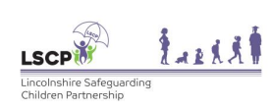
Annex B
Best practice for partner agencies when suspecting indecent images of children material

Section 1 of the Protection of Children Act 1978 creates various offences regarding the taking, making or distributing of indecent photographs (or pseudo-photographs) of a child. It is an offence for a person to:
(a) to take, or permit to be taken, or to make, any indecent photograph or pseudophotograph of a child, or

(b) to distribute or show such indecent photographs or pseudo-photographs; or

(c) to have in his/her possession such indecent photographs or pseudo-photographs, with a view to their being distributed or shown by him/herself or others. Or

(d) to publish or cause to be published any advertisement likely to be understood as conveying that the advertiser distributes or shows such indecent photographs or pseudo-photographs or intends to do so.

There is a ‘defence’ to (b) and (c) above where proceedings may not take place if the person can prove

(a) that he/her had a legitimate reason for distributing or showing the photographs or pseudo-photographs or (as the case may be) having them in his/her possession; or

(b) that he/her had not him/herself seen the photographs or pseudo-photographs and did not know, nor had any cause to suspect, them to be indecent.

When acting in the best interest of a child, the above should all be considered to ensure an individual does not commit the offence, or find themselves in a difficult position. Only Police Officers have a seizure power to retrieve evidence, and as such statutory body staff may commit an offence. Certainly, if knowing that they are taking possession of a device or item which has indecent images on, even for the reason of keeping it safe, would commit an offence and not be able to use the lawful defence under 2(b) because they know they are taking hold of the item and the images are indecent and that is the reason they have it.

The best practice is to ring the police on 101, ideally without the person who has the device knowing, to explain the circumstances and to request a Police Officer to either come and seize the device if it is soon to be destroyed, or to inform the Police about suspicions of the offence in general. If this is not possible then while accepting that it is a difficult decision, the staff member should not take possession of the device if they suspect there to be indecent images on there. If they have cause to take it for another legitimate reason, then that is their decision, but not for the indecent images.

If a member of school staff finds a pornographic image, they may dispose of the image unless they have reasonable grounds to suspect that its possession constitutes a specified offence (i.e. it is extreme or child pornography) in which case it must be delivered to the police as soon as reasonably practicable.

Advice for schools:
Searching_screening _and_confiscation.pdf
LSCP-Lincs Police-Feb 2020

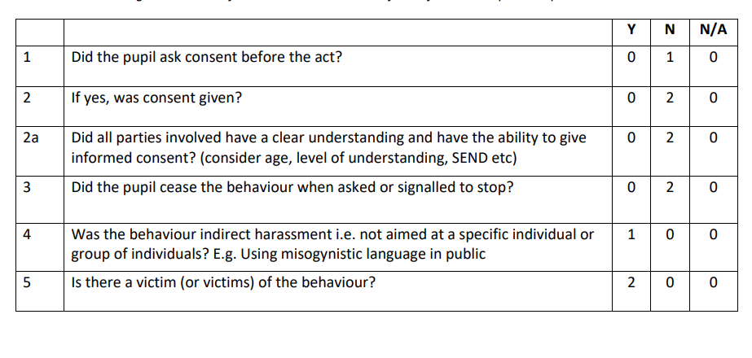
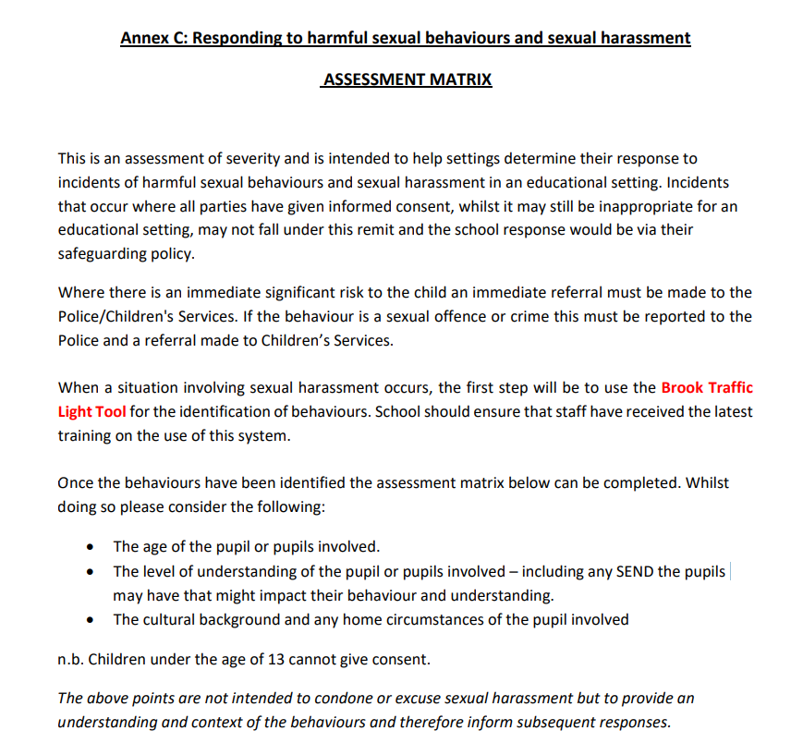
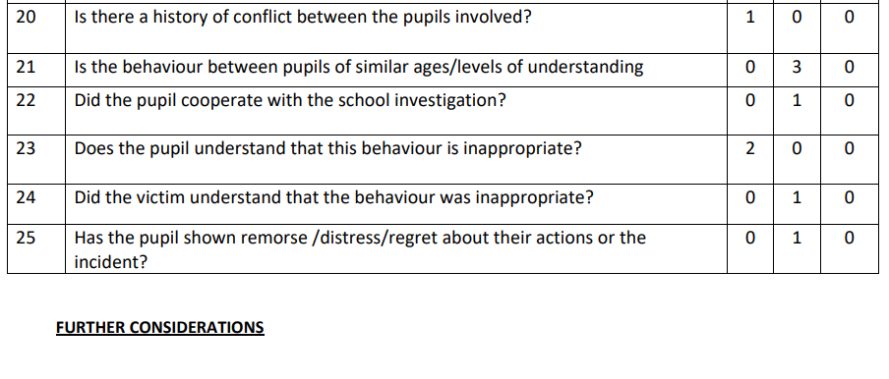
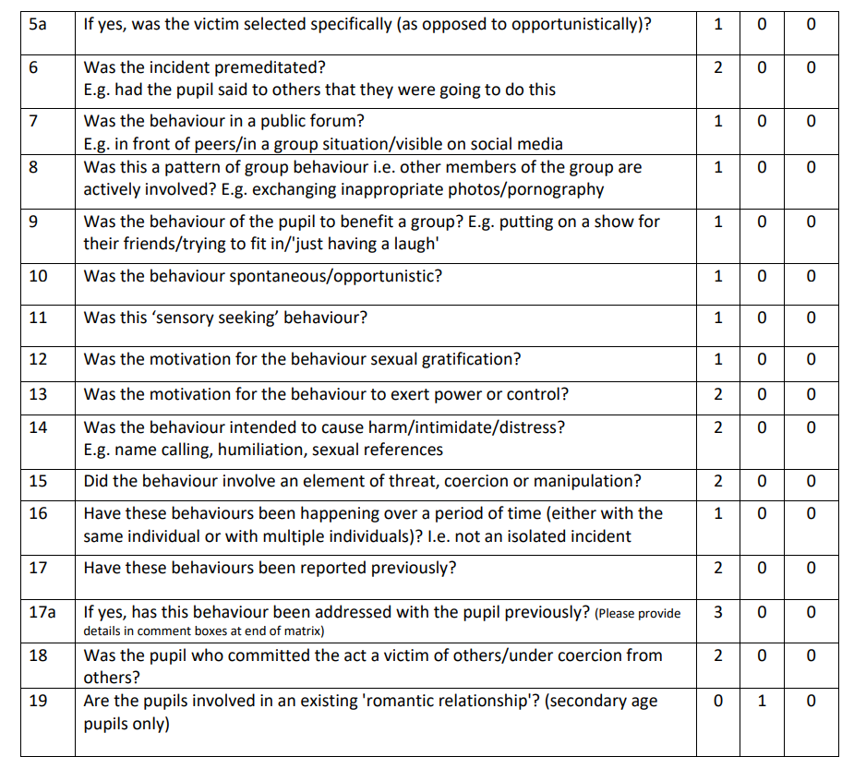
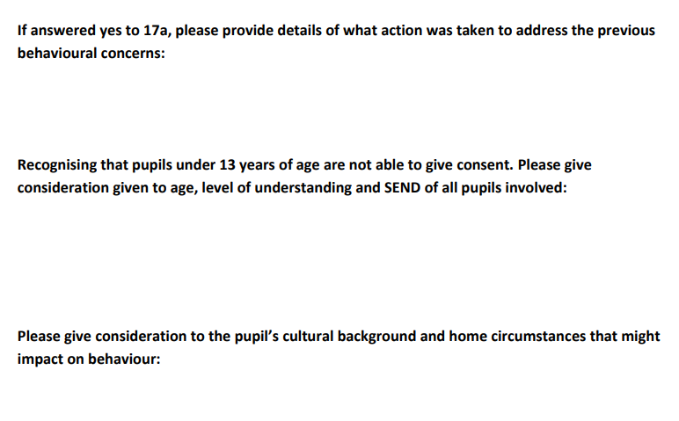

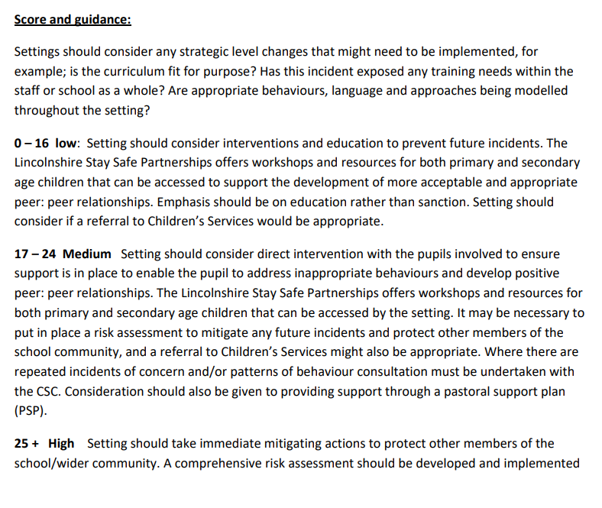

and a referral to Children’s Services would also be appropriate. Where there are repeated incidents of concern and/or patterns of behaviour consultation must be undertaken with the CSC. Setting should consider opening a pastoral support plan to ensure interventions are in place to mitigate risk, and that strategies and support is established to address the inappropriate behaviours and develop positive peer:peer relationships. The Lincolnshire Stay Safe Partnerships offers workshops and resources for both primary and secondary age children that can be accessed by the setting.



